**Static Routing Using two router and two computers**

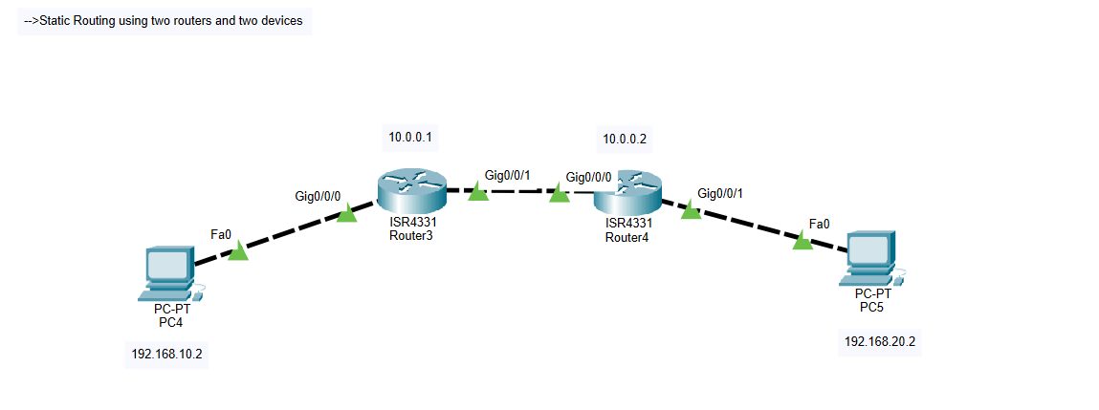

**Task 1: configure the IP and gateway on each computer**

**Task 2: make interface of routers accessible to devices IP**

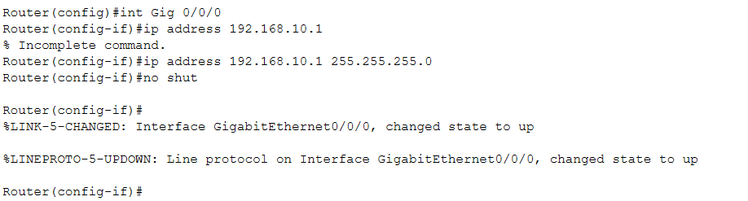

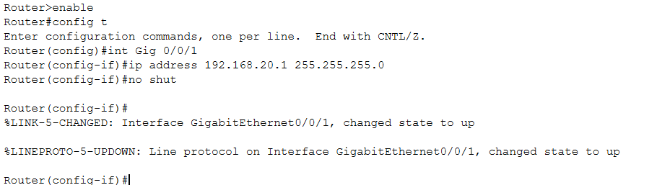

**Task 3: Giving IP address at router outgoing ports**

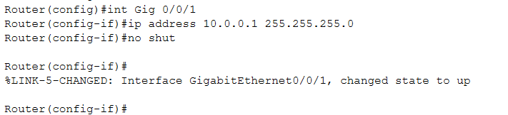

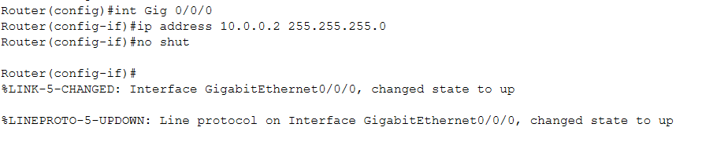

**Task 4: Routing on router 1**

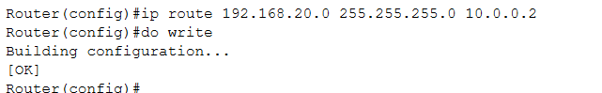

**Task 5: Reverse Routing on router 2**

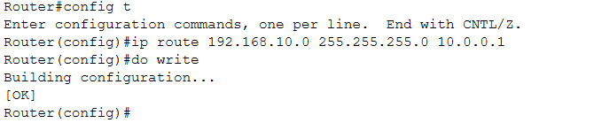

**Ping from computer 1**

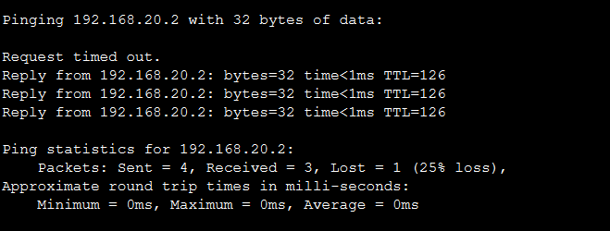

**Ping from computer 2**